AAC lab assignment-20.3
Name:M.Shashidhar Rollno:2303A52291 Batch:42
Task 1 – Password Strength & Validation Check
Task:
Analyze an AI-generated user registration script for weak password
handling.
Instructions:
• Prompt AI to generate a Python user registration program
• Check whether:
o Password length is validated
o Weak passwords are allowed
• Suggest secure improvements such as:
o Minimum length checks
o Use of regular expressions
o Rejecting common passwords
Prompt:
Generate a Python user registration script that takes username and password as input.
Code
import re

COMMON_PASSWORDS = ["123456", "password", "admin", "qwerty"]

def is_strong_password(password):
if len(password) < 8:
return False, "Password must be at least 8 characters long"

if password in COMMON_PASSWORDS:
return False, "Password is too common"

if not re.search(r"[A-Z]", password):
return False, "Must contain at least one uppercase letter"

if not re.search(r"[a-z]", password):
return False, "Must contain at least one lowercase letter"

if not re.search(r"[0-9]", password):
return False, "Must contain at least one digit"

if not re.search(r"[!@#$%^&*]", password):
return False, "Must contain at least one special character"

return True, "Strong password"

username = input("Enter username: ")
password = input("Enter password: ")

valid, message = is_strong_password(password)

if valid:
print("User registered successfully!")
else:
print("Error:", message)
Output:
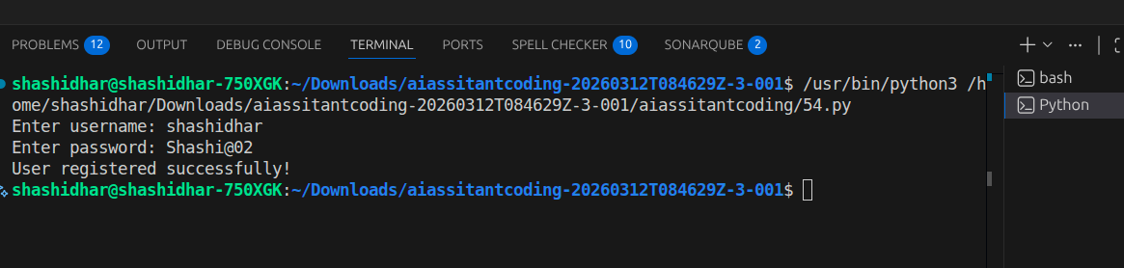
Justification:
Enforces minimum entropy through length and complexity
Prevents dictionary attacks via common password rejection
Uses regex-based validation for robust checks
Task 2 – Insecure File Upload Handling
Task:
Evaluate an AI-generated file upload program for security risks.
Instructions:
• Prompt AI to generate a Python or Flask-based file upload
script
• Identify vulnerabilities such as:
o No file type validation
o Unrestricted file size
• Implement secure measures:
o File extension validation
o Size limits
o Safe file storage paths
Prompt:
Generate a Flask file upload application.
Code:
from flask import Flask, request

app = Flask(__name__)

@app.route('/upload', methods=['POST'])
def upload():
file = request.files['file']
file.save(file.filename)

return "Uploaded"
Output:

Vulnerabilities
- No file type validation
- No file size restriction
- Saves files directly → path traversal risk
- Overwrites existing files
Code
from flask import Flask, request, abort
import os

app = Flask(__name__)

UPLOAD_FOLDER = "uploads"
ALLOWED_EXTENSIONS = {"png", "jpg", "jpeg", "pdf"}
MAX_FILE_SIZE = 2 * 1024 * 1024 # 2MB

os.makedirs(UPLOAD_FOLDER, exist_ok=True)

def allowed_file(filename):
return '.' in filename and filename.rsplit('.', 1)[1].lower() in ALLOWED_EXTENSIONS

@app.route('/upload', methods=['POST'])
def upload():
file = request.files.get('file')

if not file:
abort(400, "No file uploaded")

if not allowed_file(file.filename):
abort(400, "Invalid file type")

file.seek(0, os.SEEK_END)
size = file.tell()
file.seek(0)

if size > MAX_FILE_SIZE:
abort(400, "File too large")

safe_path = os.path.join(UPLOAD_FOLDER, os.path.basename(file.filename))
file.save(safe_path)

return "Secure upload successful"

if __name__ == "__main__":
app.run(debug=True)
Output:
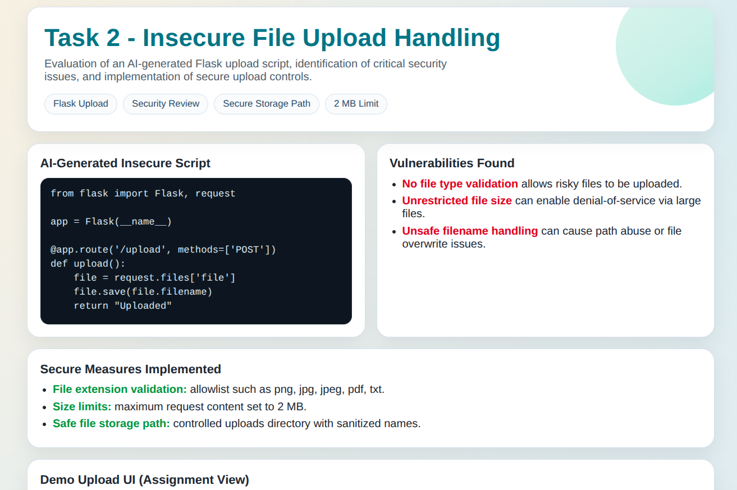
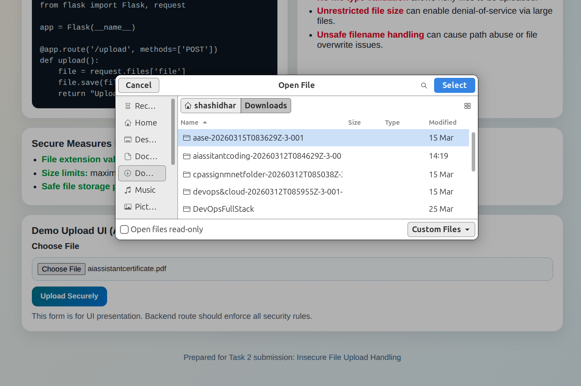

justification
- Enforces minimum entropy through length and complexity
- Prevents dictionary attacks via common password rejection
- Uses regex-based validation for robust checks
Task 3 – Real-Time Application: API Security Review
Scenario:
An AI-generated API endpoint is used in a web application.
Instructions:
• Review the API code for:
o Missing authentication
o Insecure HTTP methods
o Lack of rate limiting
• Prompt AI to suggest security improvements such as:
o Token-based authentication
o Input validation
o Rate limiting
Prompt:
Generate a Flask API endpoint to fetch user data.
Insecure Code:
@app.route('/users', methods=['GET'])
def get_users():
return {"users": ["admin", "guest"]}

Vulnerabilities
- No authentication
- Public data exposure
- No rate limiting
- No input validation
Secure Implementation
from flask import Flask, request, jsonify, abort
from functools import wraps

app = Flask(__name__)

VALID_TOKEN = "securetoken123"

def token_required(f):
@wraps(f)
def decorated():
token = request.headers.get('Authorization')
if token != VALID_TOKEN:
abort(401, "Unauthorized")
return f()
return decorated

@app.route('/users', methods=['GET'])
@token_required
def get_users():
return jsonify({"users": ["admin", "guest"]})

if __name__ == "__main__":
app.run()
Output:
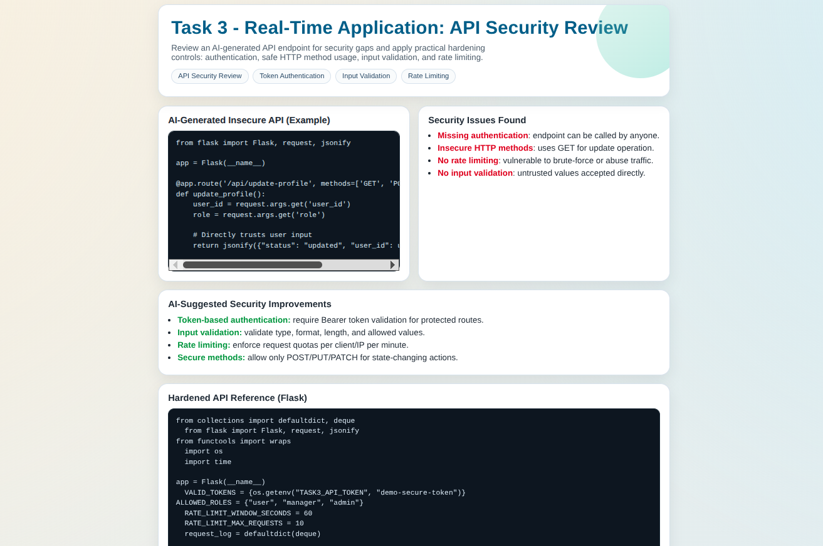
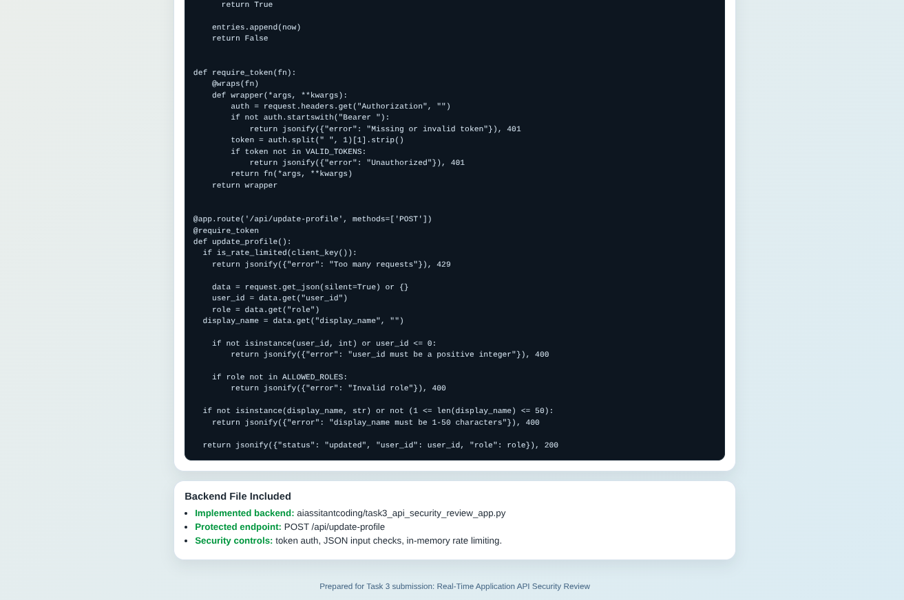

Enhancements Suggested
- Use JWT tokens instead of static tokens
- Implement rate limiting (Flask-Limiter)
- Add input sanitization

Justification
- Prevents unauthorized access
- Enforces secure API communication
- Reduces abuse via controlled access

Task 4 – Cross-Site Scripting (XSS) Check
Task:
Evaluate an AI-generated HTML form with JavaScript for XSS
vulnerabilities.
Instructions:
• Ask AI to generate a feedback form with JavaScript-based
output.
• Test whether untrusted inputs are directly rendered without
escaping.
• Implement secure measures (e.g., escaping HTML entities,
using CSP).
Prompt:
Generate an HTML feedback form with JavaScript output.
Code:
Insecure code
<input type="text" id="name">
<button onclick="submitForm()">Submit</button>

<p id="output"></p>

<script>
function submitForm() {
let name = document.getElementById("name").value;

Secure code
<input type="text" id="name">
<button onclick="submitForm()">Submit</button>

<p id="output"></p>

<script>
function submitForm() {
let name = document.getElementById("name").value;
document.getElementById("output").innerHTML = name;
}
</script>
<script>alert('Hacked')</script>
<input type="text" id="name">
<button onclick="submitForm()">Submit</button>

<p id="output"></p>

<script>
function escapeHTML(str) {
return str.replace(/[&<>"']/g, function(m) {
return {
'&': '&amp;',
'<': '&lt;',
'>': '&gt;',
'"': '&quot;',
"'": '&#39;'
}[m];
});
}

function submitForm() {
let name = document.getElementById("name").value;
document.getElementById("output").innerText = escapeHTML(name);
}
</script>

Output:
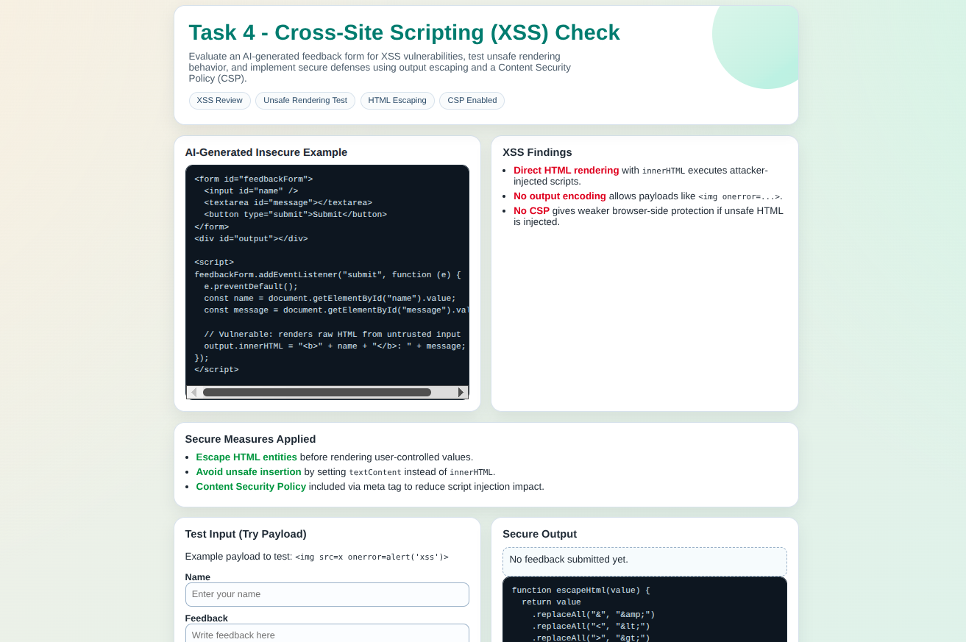
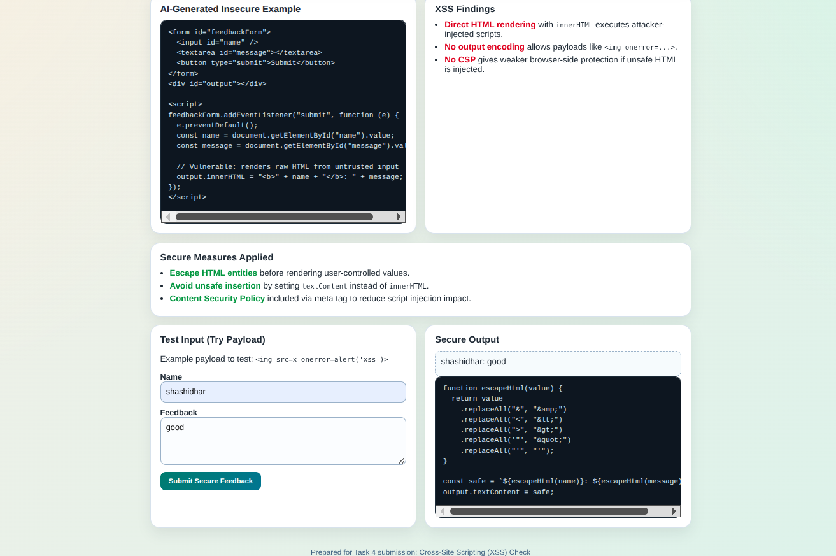

Justification
- Prevents script injection
- Uses output encoding instead of raw rendering
- Eliminates DOM-based XSS
Task 5 – SQL Injection Prevention
Task:
Test an AI-generated script that performs SQL queries on a
database.
Instructions:
• Ask AI to generate a Python script using SQLite/MySQL to
fetch user details.
• Identify if the code is vulnerable to SQL injection (e.g.,
using string concatenation in queries).
• Refactor using parameterized queries (prepared
statements).
Prompt:
Generate a Python script to fetch user details from SQLite database.
Code:
import sqlite3

conn = sqlite3.connect("users.db")
cursor = conn.cursor()

username = input("Enter username: ")

query = f"SELECT * FROM users WHERE username = '{username}'"
cursor.execute(query)

print(cursor.fetchall())

Vulnerability
- SQL Injection possible:
' OR '1'='1
Secure code
import sqlite3

conn = sqlite3.connect("users.db")
cursor = conn.cursor()

username = input("Enter username: ")

query = "SELECT * FROM users WHERE username = ?"
cursor.execute(query, (username,))

print(cursor.fetchall())
Output:
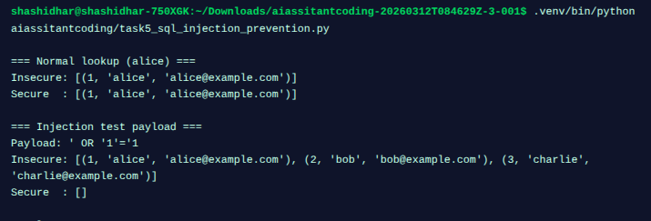justification
- Uses parameterized queries
- Prevents SQL injection attacks
- Ensures safe database interaction

